BETH HART
ANNOUNCES APRIL/MAY 2018 UK TOUR
HOT ON THE HEELS OF HER SOLD OUT CONCERT AT THE ROYAL ALBERT HALL

TICKETS ON SALE FRIDAY 6th OCTOBER

“Beth Hart has a blues-rock voice so ballsy,
it could pin you to the wall.” - The Times

GRAMMY AWARD NOMINATED AMERICAN
SINGER SONGWRITER ANNOUNCES
HER BIGGEST UK TOUR TO DATE

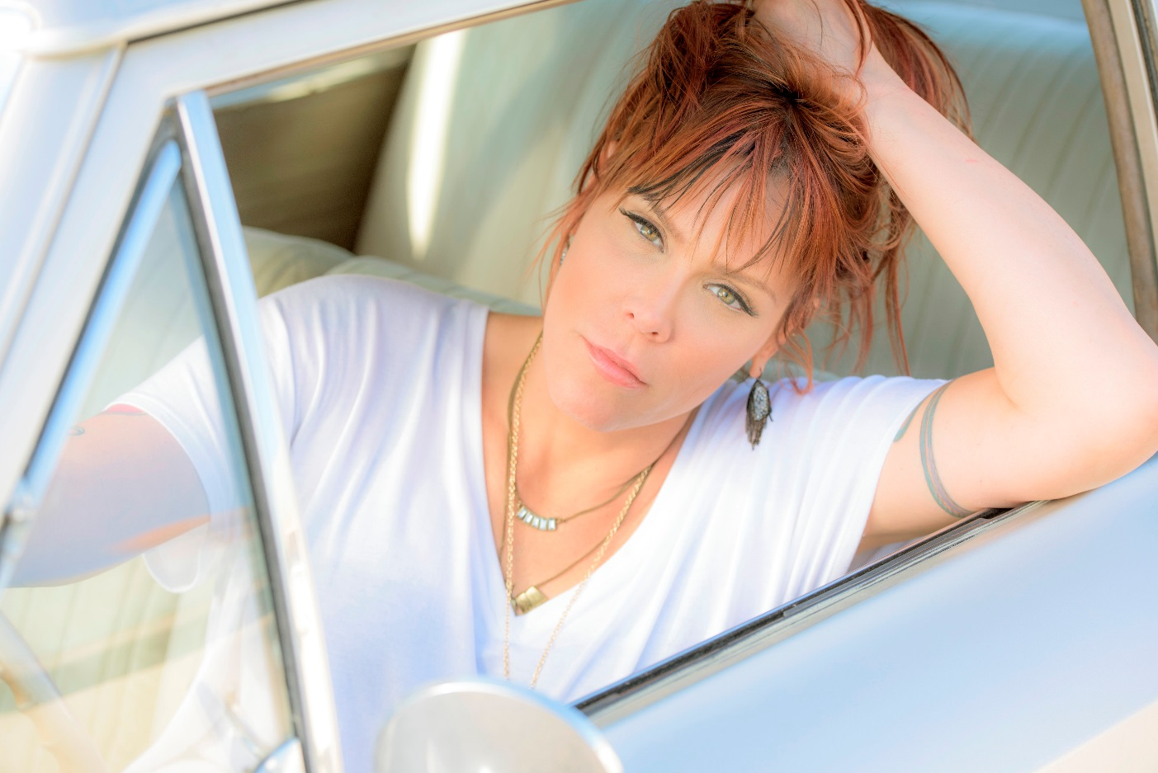

TICKETS ON SALE FRIDAY 6th OCTOBER 2017
www.alttickets.com/beth-hart-tickets
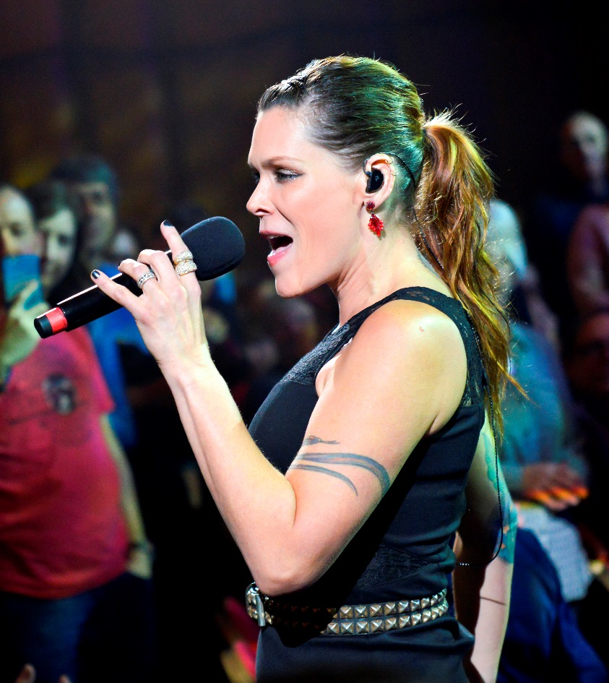
“Beth Hart has the vulnerability of Piaf and the power of Aretha, she can shatter windows... and she can touch hearts.”
– / Birmingham Mail

Photo by Paul Sabine

Having sold out her biggest UK concert at London’s prestigious Royal Albert Hall on Friday 4th May 2018, Grammy nominated singer-songwriter Beth Hart and her band will embark on a 14-date UK & Irish tour in April and May 2018.

The tour will start at Dublin’s Vicar Street on Tuesday 10th April 2018 culminating in the sold out concert at London’s Royal Albert Hall on Friday 4th May.

Tickets for the tour will go on sale on Friday 6th October at 10am from www.alttickets.com/beth-hart-tickets.

There are limited tickets remaining for Beth’s three solo UK shows at Leeds Town Hall on Monday 30th October 2017, Bath Forum on Wednesday 1st November 2017, and Coventry Cathedral on Friday 3rd November 2017. Further information on Beth Hart’s solo shows.

BETH HART
APRIL/MAY 2018 UK TOUR

DUBLIN VICAR STREET
TUESDAY 10th APRIL 2018
VENUE BOX OFFICE: +353 1 775 5800
BOOK ONLINE: http://www.ticketmaster.ie/venueartist/198259/935151
TICKETS: www.bethhart.com/tour
58-59 THOMAS ST, THE LIBERTIES, DUBLIN 8, IRELAND
http://www.vicarstreet.ie/

IPSWICH REGENT THEATRE
THURSDAY 12th APRIL 2018
VENUE BOX OFFICE: 01473 433100
BOOK ONLINE: www.alttickets.com/beth-hart-tickets
TICKETS: www.bethhart.com/tour
3 ST. HELEN'S ST, IPSWICH IP4 1HE
https://apps.ipswich.gov.uk/

BEXHILL DE LA WARR PAVILION
SATURDAY 14th APRIL 2018
VENUE BOX OFFICE: 01424 229111
BOOK ONLINE: www.alttickets.com/beth-hart-tickets
TICKETS: www.bethhart.com/tour
MARINA, BEXHILL-ON-SEA TN40 1DP
https://www.dlwp.com/

NOTTINGHAM ROYAL CONCERT HALL
SUNDAY 15th APRIL 2018
VENUE BOX OFFICE: 0115 989 5555
BOOK ONLINE: www.alttickets.com/beth-hart-tickets
TICKETS: www.bethhart.com/tour
THEATRE SQUARE, NOTTINGHAM NG1 5ND
https://trch.co.uk/

OXFORD NEW THEATRE
WEDNESDAY 18th APRIL 2018
VENUE BOX OFFICE: 0844 871 3020
BOOK ONLINE: www.alttickets.com/beth-hart-tickets
TICKETS: www.bethhart.com/tour
GEORGE ST, OXFORD OX1 2AG
http://www.atgtickets.com/venues/new-theatre-oxford/

FOLKESTONE LEAS HALL
THURSDAY 19th APRIL 2018
VENUE BOX OFFICE: 01303 228600
BOOK ONLINE: www.alttickets.com/beth-hart-tickets
TICKETS: www.bethhart.com/tour
THE LEAS, FOLKESTONE CT20 2DZ
http://www.atgtickets.com/venues/leas-cliff-hall//

CARDIFF ST DAVID HALL
SATURDAY 21st APRIL 2018
VENUE BOX OFFICE: 029 2087 8444
BOOK ONLINE: www.alttickets.com/beth-hart-tickets
TICKETS: www.bethhart.com/tour
9-11 THE HAYES, CARDIFF CF10 1AH
http://www.stdavidshallcardiff.co.uk/

CAMBRIDGE CORN EXCHANGE
TUESDAY 24th APRIL 2018
VENUE BOX OFFICE: 01223 357851
BOOK ONLINE: www.alttickets.com/beth-hart-tickets
TICKETS: www.bethhart.com/tour
2 WHEELER ST, CAMBRIDGE CB2 3QB
https://www.cambridgelivetrust.co.uk/cornex/

BLACKPOOL OPERA HOUSE
THURSDAY 26th APRIL 2018
VENUE BOX OFFICE: 0844 856 1111
BOOK ONLINE: www.alttickets.com/beth-hart-tickets
TICKETS: www.bethhart.com/tour
97 CHURCH ST, BLACKPOOL FY1 1HL
http://www.wintergardensblackpool.co.uk/venue/opera-house/

HULL CITY HALL
FRIDAY 27th APRIL 2018
VENUE BOX OFFICE: 01482 300306
BOOK ONLINE: www.alttickets.com/beth-hart-tickets
TICKETS: www.bethhart.com/tour
QUEEN VICTORIA SQUARE, CARR LN, HULL HU1 3RQ
https://www.hulltheatres.co.uk/

READING HEXAGON
MONDAY 30th APRIL 2018
VENUE BOX OFFICE: 0118 960 6060
BOOK ONLINE: www.alttickets.com/beth-hart-tickets
TICKETS: www.bethhart.com/tour
QUEENS WALK, BERKSHIRE, READING, READING RG1 7UA
https://www.readingarts.com/hexagon

PORTSMOUTH GUILDHALL
TUESDAY 1st MAY 2018
VENUE BOX OFFICE: 023 9387 0200
BOOK ONLINE: www.alttickets.com/beth-hart-tickets
TICKETS: www.bethhart.com/tour
GUILDHALL SQUARE, PORTSMOUTH PO1 2AB
http://www.portsmouthguildhall.org.uk/

SOLD OUT LONDON ROYAL ALBERT HALL SOLD OUT
FRIDAY 4th MAY 2018
PLUS SPECIAL GUEST
VENUE BOX OFFICE: 020 7589 8212
BOOK ONLINE: www.alttickets.com
BOOK ONLINE: www.royalalberthall.com/tickets
TICKETS: www.bethhart.com/tour
KENSINGTON GORE, LONDON, SW7 2AP
www.royalalberthall.com

CHELTENHAM JAZZ FESTIVAL
SATURDAY 5th MAY 2018
TICKETS GO ON SALE ON FRIDAY 3 NOVEMBER
VENUE BOX OFFICE: 01242 850270
BOOK ONLINE: http://www.cheltenhamfestivals.com/jazz/whats-on/2018/beth-hart/
TICKETS: www.bethhart.com/tour

www.cheltenhamfestivals.com/jazz/

"I'm sure it will not be long before Beth Hart is back again so tell your friends and go along. It will be one of, if not the best gig you will go to all year." – Bournemouth Daily Echo

"Her personal struggles have defined her and her music and the end result is an assured performer who connects totally with her crowd and her pain has given her an enviable oeuvre that she never fails to deliver with passion, commitment, humour and grace." - Bristol24/7
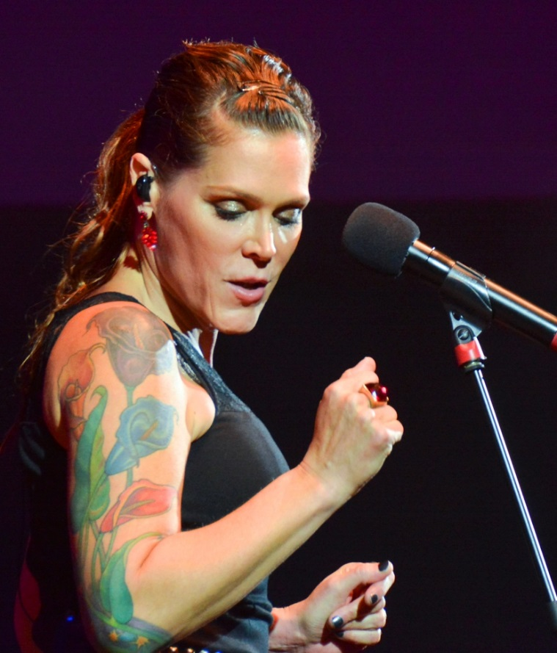

Photo by Liz Aiken

“With every album and tour she seems to go from strength to strength. Beth Hart is one of the truly great singer-songwriters of our time, a genre-defying powerhouse vocalist.” – National Rock Review

“There are singers, there are good singers - and then there is Beth Hart.
The Bridgewater Hall was the latest in a series of sold out venues around the UK to experience the power, passion and purity of this extraordinary artist.” – Lancashire Telegraph

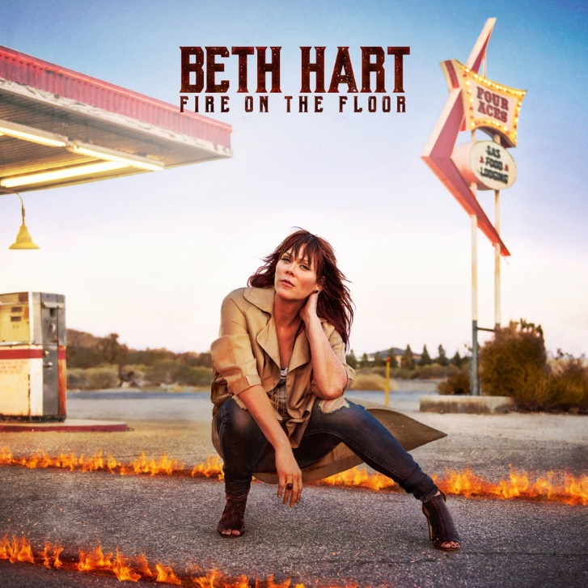
“The personal anecdotes that introduced each solo performance made songs such as the already poignant 'Mama This One's For You' and the simple but elegant 'No Place Like Home' all the more emotive and all the more powerful.” – Fabrications
Beth Hart's latest album "Fire On The Floor"
is available on LP+MP3, CD and Digital
from Amazon UK

BETH HART – BIOGRAPHY

It’s that voice. When Beth Hart sings, clocks stop, hearts dance and neck-hair tingles. And when she tells her rollercoaster story, in a West Coast drawl that could distil whisky at fifty paces, it’s every bit as compelling. “There was definitely difficult stuff,” she reflects, “but there was incredible stuff as well. I wouldn’t change any of it, because you bring your experiences to the music.”

Picture the scene. It’s midnight in the mid-’70s, and in a slumbering Los Angeles family home, four-year-old Beth Hart is about to cause her first musical disturbance. “There was this commercial for pianos on TV,” she recalls, “and the music was Beethoven’s Moonlight Sonata, which was the most beautiful thing I’d ever heard. So in the middle of the night, I got up and played part of that song on the piano. My mother, father and all the other kids came out and they gave me so much love and attention, I knew right away this little ham had to have it. So I always knew I wanted to do it. I just knew…”

Her passion never wavered, but the road to Hart’s stunning last album, Bang Bang Boom Boom, was far from a smooth ride, and you hear every bump in her unflinching lyrics and soulful delivery. “I never thought I’d be a singer,” she says. “I thought I’d be a classical pianist or cellist, go to Juilliard. When I did start singing, I took opera lessons and my teacher was wonderful, but one day she goes, ‘Beth, I don’t think classical is for you, because you like to do your own thing with the music’. That’s when I started putting singing to my own music.”

If Hart’s back catalogue is eclectic, her formative tastes were even more so, taking in jazz, rock, blues, gospel and grunge. “Billie Holiday and Ella Fitzgerald: I’m fascinated by them,” she says, “But then when I heard Robert Plant and Chris Cornell, I couldn’t get over their power. But then, Rickie Lee Jones and James Taylor, their voices were so lovely and soft…”

Beth paid her dues with an acoustic guitar around LA. Her big break came in 1993, when a $50 bet with a friend led her onto a TV talent show.“ And I won,” she grins. “I won a lot of money, over $100,000. Instead of being happy the night I won, I went into total depression, I was so afraid of the pressure. But boy, I took that money. I lived in a basement, and my piano was full of roaches, so I got new furniture, moved into a great apartment. I was on cloud nine. I did a lot of drugs. I spent that money in less than six months.”

Signed to Atlantic Records, Beth worked with top producers on 1996’s Immortal, and scored international hits with cuts like Am I The One, but today, she contends it was on 1999’s Screamin’ For My Supper – home to the smash-hit LA Song (Out Of This Town) – that she found her voice. “If I could have my way,” she says, “I’d love it if people bought my new album and Screamin’ For My Supper simultaneously, because I think that record is where I became a real writer.”

But again, pressure clipped her wings. A heady cocktail of drugs and Beth’s unmedicated bipolar disorder ensured that her Atlantic deal went sour, and it took the intervention of road manager Scott Guetzkow to pull her back from the brink. “I went into five different hospitals that year, not including rehabs,” she says. “It was so bad that I remember talking to my psychologist and he said, ‘I don’t think you can handle being in this business…’”

Around the turn of the millennium, Beth ditched her “drug of choice” (Klonopin), drove to Vegas, married Guetzkow and never looked back. Though her feet stayed on the ground, the musical highs returned. In 2003, she shot back with third album, Leave the Light On (Billboard: “One of the year’s most affecting albums), while in 2005, her popularity on the continent was thrillingly bottled by the Live at Paradiso release from Amsterdam. In 2007, 37 Days gave Beth the European hit Good As It Gets, and in 2010, My California found her singing with new sensitivity about personal themes, in particular the loss of her beloved sister, Sharon, on Sister Heroine.

While the buzz grew, that voice had caught some famous ears, and to date, Beth counts some of rock’s most iconic guitarists amongst her collaborators. Her earliest A-list hook-up was alongside British veteran Jeff Beck (“I didn’t know a guitar could sound that way”), while she enjoyed fizzing chemistry with ex-Guns N’ Roses legend Slash, who guested on Sister Heroine and co-wrote Mother Maria for the Download To Donate For Haiti charity album. “As you can imagine,” Beth admits, “I was quite nervous. His personality is the absolute opposite to mine. I’m pretty high-strung when I’m working, and he’s very mellow.”

It was a chance meeting with the blues star Joe Bonamassa in a hotel lobby that changed her trajectory, resulting in an invitation to sing on the Kevin Shirley-produced soul-rock covers album that became 2011’s Don’t Explain. “I said, ‘are you kidding me?” she laughs of her response. “We made a big list of covers over the phone, but we only recorded for four days. We instantly clicked.”

With cuts like I’ll Take Care of You hijacking BBC Radio 2’s playlists in the UK, and Classic Rock including the release in its Top Albums of 2011, Don’t Explain proved to be Hart’s tipping-point and the perfect springboard for Bang Bang Boom Boom. With 11 original songs recorded live by Kevin Shirley, this new collection gives Beth’s eclectic influences free rein, spinning from Spirit of God’s brassy gospel to the sparse Thru The Window of My Mind, with her first-ever piano solo on Swing My Thing Back Around, and an impossibly tender vocal on the Billie Holiday-flavoured Baddest Blues.

More than that, though, it’s the album where Beth is finally able to admit she might actually be happy. “Often on old records, I wrote about pain and fear,” she says. “I didn’t write so much about love. I always felt like I didn’t understand it or wasn’t worthy. This is the first album where I have, and it’s such a beautiful feeling. I feel like I’ve gotten to fit into a new pair of shoes, y’know, and I can walk a different walk. Every album is special to me. But with this one, there’s a real specialness about it, because I’m at a different age and in a new headspace.”

Seesaw reunites force-of-nature blues rock vocalist Beth Hart and guitar hero Joe Bonamassa for a second album of choice covers from various musical eras. As with their first outing, Don’t Explain, the project is in collaboration with producer Kevin Shirley (Led Zeppelin, Aerosmith, Black Crowes). Each of the three principals suggested and selected tracks for the 11-song set list, which mines soulful classics previously made famous by Aretha Franklin, Etta James, Billie Holiday, Donnie Hathaway, Lucinda Williams, Buddy Miles, Tina Turner, Slackwax, Melody Gardot, and Nina Simone.

Hart’s powerhouse vocals and Bonamassa’s scorching solos honour and reinvent the original recordings. They’re backed by the same world class band that kept the grooves going on Don’t Explain: Anton Fig (drums, percussion), Carmine Rojas (bass), Blondie Chaplin (rhythm guitar, backing vocals and percussion), Arlan Schierbaum (organ, piano). This time out, their mighty sound is augmented by a horn section, with Lee Thornburg on trumpets and trombones, and Ron Dziubla on saxophones.

For Hart and Bonamassa, making music together grew out of the friendship and mutual artistic appreciation they developed after crossing paths on the road numerous times, particularly on the festival circuit in Europe. Bonamassa wanted to do a project with her, and came up with the idea for a soul covers record. Shirley, who’s produced 12 of Bonamassa’s albums, was enthusiastic, and Bonamassa contacted Hart. “When I got the call that he wanted to do a soul record with me, I figured I’d be the background singer. He said ‘no, you’re singing lead.’” The chemistry clicked, and

Don’t Explain was released in 2011, followed now by 2013’s Seesaw and a mini joint European tour —in between, both Hart and Bonamassa have toured, recorded solo albums, and reached new career highs.

For the album Seesaw, Beth Hart and Joe Bonamassa received a Grammy nomination in the category: Best Blues Album. “This is a really happy day for me and I’m really proud and have so many people to be thankful for, but I am most thankful for my husband Scott, for without him there’s no way I’d be able to still be here enjoying the love of music and life.”
Beth Hart is also nominated for a Blues Music Award in the category: Best Contemporary Female Blues Artist.

It was finally Australia’s turn to be introduced in person to Beth Hart when she made her debut appearance on their shores for the Byron Bay BluesFest’s 25th Anniversary in April 2014. Beth Hart was one of BluesFest’s director’s top picks. Director Peter Noble went overboard for her. The album Bang Bang Boom Boom was released in Australia in March 2014.
In 2015, Beth released the critically acclaimed studio album Better Than Home and toured the globe. Right now, she is currently putting the finishing touches to a new studio album which is set to be released in 2016, followed by a world tour.

In October 2016, Beth released her current studio album Fire On The Floor to critical acclaimed and performed a sold out UK tour in November which garnered who rave reviews.

BETH HART

OFFICIAL WEBSITE FACEBOOK TWITTER

For further information please contact:
Peter Noble at Noble PR Consultancy
0207 272 7772, peter@noblepr.co.uk

